KEY PROJECTS

+31 625060761
Joeypiek.jp@gmail.com
LinkedIn Profile


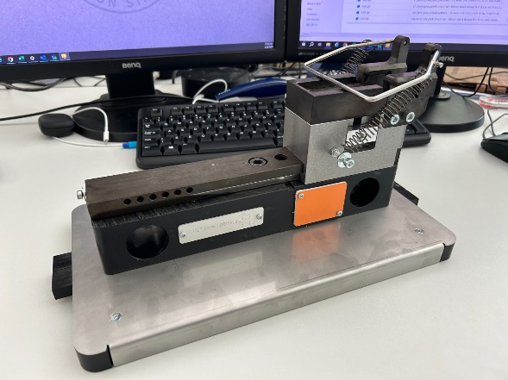
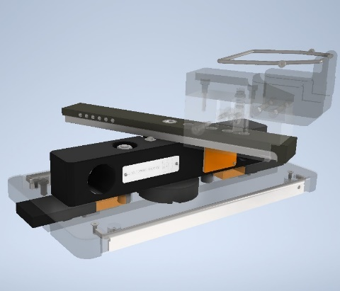
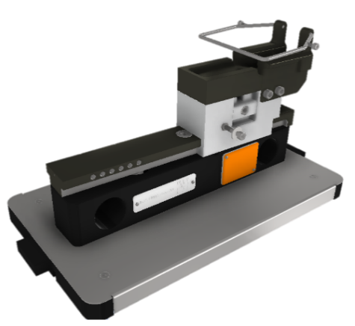
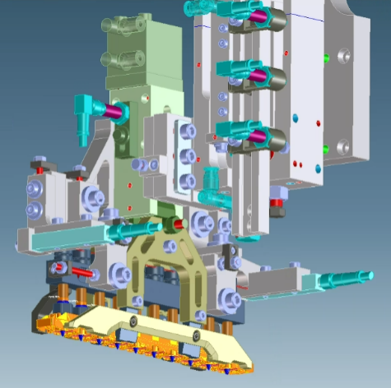
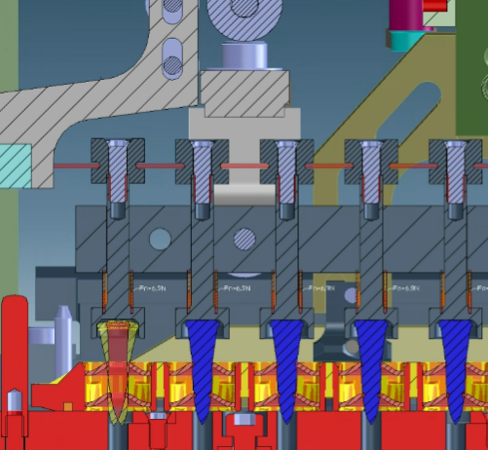
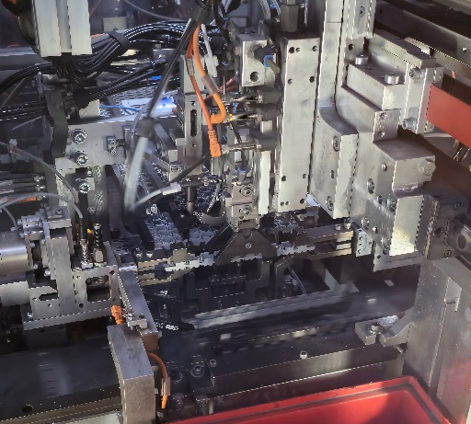

Sandals last carrier
What?
- Internship task at Birkenstock
- Copy dimensions and parts of the current Last carrier and convert them to 3D and 2D CAD files for manufacturer so that it can be reproduced

How?
- Measured dimensions by hand
- Used Autodesk Inventor to draw out all the parts and materials
- Created files that are compatible with all programs

Results
- Fully finished 3D and 2D rework of the current Last carrier ready for manufacturing
- Gained experience with CAD design, mainly Autodesk Inventor
Inline monitoring sensor system
What?
- Final thesis internship project at Hilti
- Acted as project manager responsible for developing and implementing an inline detection system to verify completeness and alignment of X-ENP19-LP15MX nail magazine strips
- Goal: ensure 100% detection of missing, protruding, or misaligned nails to improve product quality and customer satisfaction
How?
- Managed the full project: concepting, budgeting, design, supplier coordination, manufacturing, and implementation
- Led technical analysis and concept selection using HIRA and cost-effectiveness evaluation
- Oversaw design and integration of a mechanical detection system with spring-loaded pins and laser sensors
- Coordinated with supplier and internal teams to ensure seamless integration into the assembly line
Results
- Delivered a fully implemented inline detection system meeting all key requirements within the budget
- Achieved reliable detection of missing, protruding, and misaligned nails with no impact on OEE for good parts
- Gained experience managing an industrial engineering project including concept development, supplier management, budget control, technical design, and implementation leadership
KEY PROJECTS

+31 625060761
Joeypiek.jp@gmail.com
LinkedIn Profile

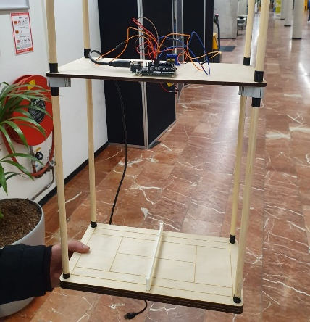
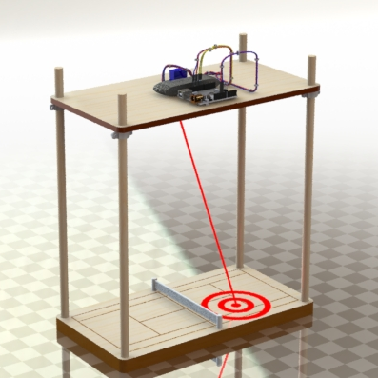
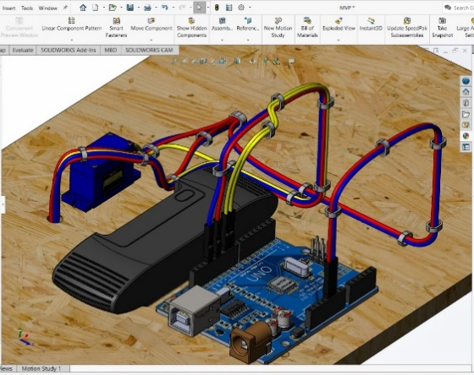
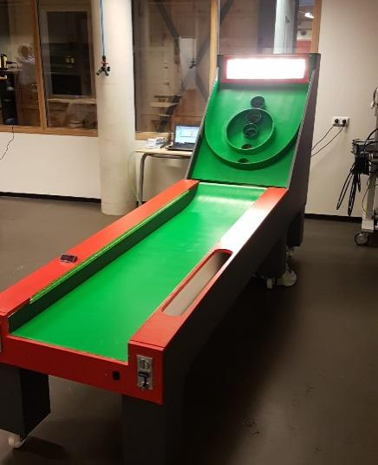
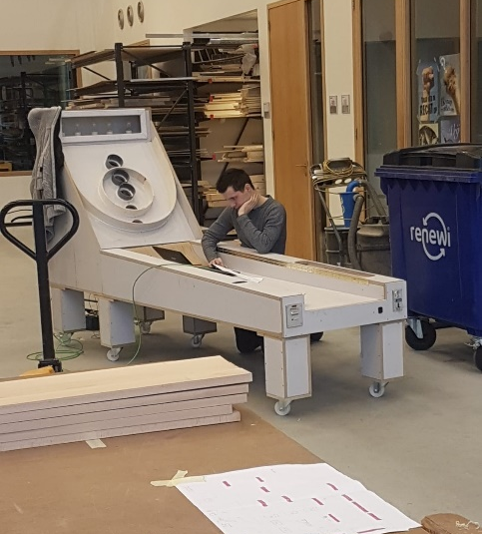
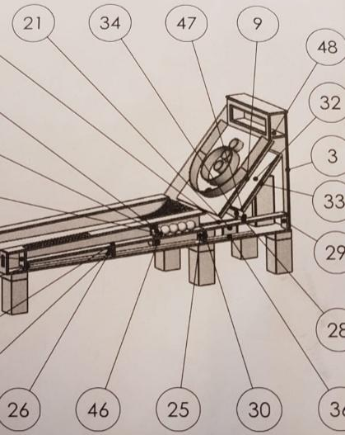
What?
- Vocational education level 4 graduation project
- Design a project of our own choosing with plenty technical depth and documentation
- Created a skee-ball machine, which is an arcade game where players roll balls up a ramp to jump into holes with different point values

How?
- Used SolidWorks to design the main body and interior
- Bought cheap components that were easy to connect and install
- Connected all components to 24V power converter
- Controlled the system with a PLC
Build the main body with wood and an inner layer of steel support

Results
- Completed the project with a 9 as final grade
- The project was shipped to the city Groningen where it was put on display for anyone to see and use
- Gained experience with CAD Design, PLC programming, electrical schematics and Woodworking
Tennis Smart Court POC
Skee-ball machine



What?
- Project for the minor: Technology to Innovate
- Create an innovative prototype that appeases the wishes of the client
- Make tennis more interesting while also aiding in training
- Do comprehensive research and a market analysis create a unique and innovative project
How?
- Used SolidWorks to design the main body and position the components
- Utilized a Logitech camera and computer vision to measure ball and player statistics
- Controlled system using an Arduino and laptop running a Python program
- Used a laser mounted on two servos to aim the laser at the playing field, which is also how we projected the games
- Utilized laser cutter and 3D printer for wood and the “net”
- Used laptop as feedback screen for the player
Results
- Completed the project with an 8.5 as final grade
- Achieved theoretical estimated increase of 30% in the club members when deployed, which roughly translates to 120 members
- Gained additional experience with computer vision, CAD design, Python programming, 3D printing and Laser cutting

KEY PROJECTS

+31 625060761
Joeypiek.jp@gmail.com
LinkedIn Profile

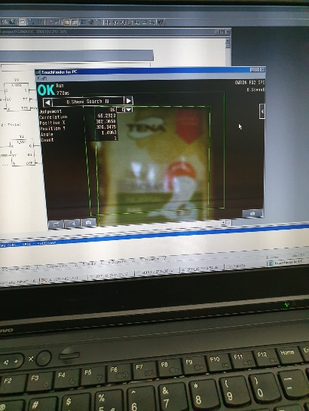
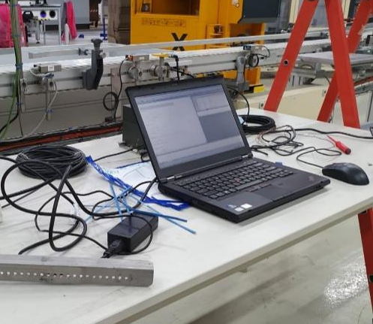
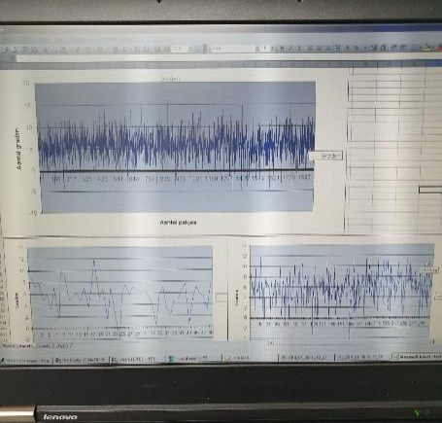


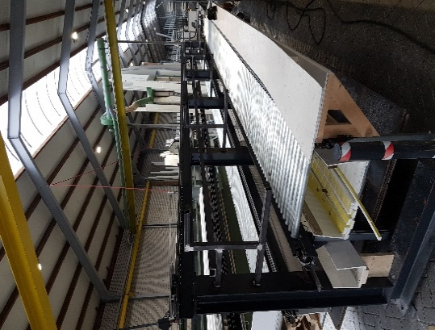
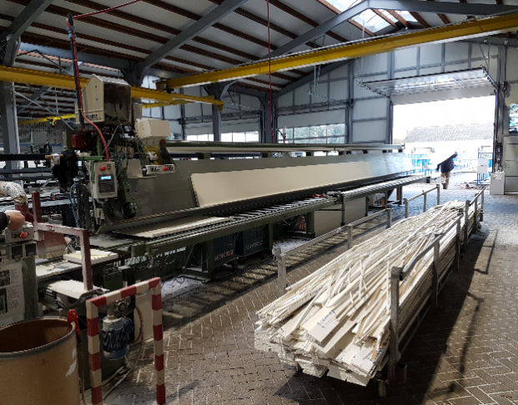
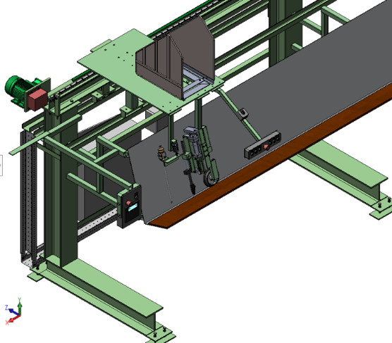
Automotive Engineering
Mechanical Engineering
Electrical Engineering
Hybrid Technology
Electric Vehicles (EV)
Internal Combustion Engine (ICE)
Transmission Systems
Drivetrain
Powertrain
Battery Management Systems (BMS)
Fuel Efficiency
Aerodynamics
Computational Fluid Dynamics (CFD)
Vehicle Dynamics
Suspension Systems
Brake Systems
Steering Systems
Active Safety
Passive Safety
Crashworthiness
Advanced Driver-Assistance Systems (ADAS)
Autonomous Vehicles
Sensor Fusion
LIDAR
RADAR
Camera Systems
Telematics
Infotainment Systems
Human-Machine Interface (HMI)
User Experience (UX)
User Interface (UI)
Software Development
Embedded Systems
Real-Time Operating Systems (RTOS)
Vehicle-to-Vehicle (V2V)
Vehicle-to-Infrastructure (V2I)
Connectivity Solutions
Cybersecurity
Cloud Computing
Big Data Analytics
Machine Learning
Artificial Intelligence (AI)
Predictive Maintenance
Diagnostics
Materials Science
Lightweight Materials
Composite Materials
Noise, Vibration, and Harshness (NVH)
Thermal Management
HVAC Systems
Emissions Control
Exhaust Systems
Catalytic Converters
Particulate Filters
Alternative Fuels
Hydrogen Fuel Cells
Regenerative Braking
Tire Technology
Aerodynamic Design
Wind Tunnel Testing
Prototyping
CAD (Computer-Aided Design)
CAM (Computer-Aided Manufacturing)
CAE (Computer-Aided Engineering)
Finite Element Analysis (FEA)
Quality Assurance
Quality Control
Supply Chain Management
Lean Manufacturing
Six Sigma
Project Management
Product Lifecycle Management (PLM)
Industrial Design
Automotive Styling
Color and Trim
Lighting Systems
Seating Systems
Safety Standards
Regulatory Compliance
Intellectual Property
Patent Strategy
Market Analysis
Consumer Behavior
Brand Management
Competitive Analysis
Globalization
Localization
Testing and Validation
Homologation
Warranty Analysis
Recall Management
Customer Service
Aftermarket
Retrofitting
Fleet Management
Mobility Solutions
Urban Planning
Sustainable Transportation
Environmental Impact Assessment
Life Cycle Assessment
Tamil
Persian (Farsi)
Arabic
Thai
Turkish
Punjabi
Javanese
Telugu
Marathi
Europe:
English
Russian
German
French
Spanish
Italian
Ukrainian
Polish
Romanian
Dutch
Greek
Hungarian
Portuguese
Czech
Swedish
Serbian
Bulgarian
Finnish
Danish
Norwegian
Icelandic
Middle East and Central Asia:
Arabic
Persian (Farsi)
Turkish
Hebrew
Uzbek
Azerbaijani
Kazakh
Pashto
Kurdish
Armenian
Dari
Oceania:
English (various dialects)
Māori
Hawaiian
Samoan
Fijian
Tahitian
Palauan
Bislama
Tok Pisin
Tongan
Swiss German
Frisian
Dutch
English
German
French
Italian
Spanish
Russian
Polish
Dutch
Greek
Portuguese
Swedish
Danish
Finnish
Norwegian
Hungarian
Czech
Romanian
Bulgarian
Slovak
Turkish

English
Mandarin Chinese
Hindi
Spanish
French
Standard Arabic
Bengali
Russian
Portuguese
Indonesian
Urdu
German
Japanese
Swahili
Marathi
Telugu
Turkish
Korean
Tamil
Italian
Africa:
Swahili
Amharic
Yoruba
Oromo
Hausa
Igbo
Zulu
Somali
Berber
Arabic
Afrikaans
Malagasy
Americas:
English
Spanish
Portuguese
French
Quechua
Mayan languages
Guarani
Aymara
Nahuatl
Creole languages
Inuit languages
Asia:
Mandarin Chinese
Hindi
Bengali
Urdu
Indonesian
Japanese
Tagalog (Filipino)
Vietnamese
Korean

Agile Development
SCRUM
Feedback Loops
Industrial Robots
Collaborative Robots (Coots)
Vision Systems
Laser Technology
Ultrasonic Sensors
Infrared Sensors
Capacitive Sensing
Inductive Sensing
Touchscreen Technology
User Interface Design
User Experience
Rapid Application Development
Systems Analysis
Operational Efficiency
Predictive Maintenance
Root Cause Analysis
Failure Mode and Effects Analysis (FMEA)
Statistical Process Control (SPC)
Process Optimization
Lean Six Sigma
Kaizen
5S Methodology
Value Stream Mapping
Kanban Systems
JIT (Just-In-Time) Manufacturing
Product Lifecycle Management (PLM)
Finite Element Analysis (FEA)
Computational Fluid Dynamics (CFD)
Thermodynamics
Mechanics of Materials
Electronic Design Automation (EDA)
VHDL (VHSIC Hardware Description Language)
Verilog
FPGA (Field-Programmable Gate Array)
ARM Architecture
Embedded Linux
Real-Time Operating Systems (RTOS)
Microelectromechanical Systems (MEMS)
Nanotechnology
Semiconductor Physics
Analog Circuits
Digital Circuits
Signal Integrity
Electromagnetic Compatibility (EMC)
Antenna Design
RF (Radio Frequency) Engineering
Mixed-Signal Processing
Power Management
Solar Energy Systems
Wind Energy Systems
Energy Storage Systems
Electric Vehicles
Smart Grids
Home Automation
Building Automation
Industrial Ethernet
Time-Sensitive Networking (TSN)
OPC UA (Open Platform Communications Unified Architecture)
MQTT (Message Queuing Telemetry Transport)
Data Logging
Cloud Computing
Edge Computing
Big Data Analytics
Data Mining
Cyber-physical Systems
Cybersecurity
Blockchain Technology
Augmented Reality (AR)
Virtual Reality (VR)
Digital Twin
Additive Manufacturing
Subtractive Manufacturing
Material Requirements Planning (MRP)
Enterprise Resource Planning (ERP)
Customer Relationship Management (CRM)
Supply Chain Optimization
Global Positioning System (GPS)
Geographical Information Systems (GIS)
Drone Technology
Mobile Development
Web Development
API (Application Programming Interface) Development
Software Testing
Quality Assurance
DevOps
Containerization
Kubernetes
Docker
CI/CD (Continuous Integration/Continuous Deployment)
Machine Ethics
Human-Robot Interaction
Adaptive Control
Nonlinear Control
Quantum Computing
Wearable Technology
Biomechatronic
Teleoperation
Systems Engineering
Mechanical Engineering
Electrical Engineering
Civil Engineering
Chemical Engineering
Aerospace Engineering
Environmental Engineering
Software Engineering
Industrial Engineering
Biomedical Engineering
Agricultural Engineering
Material Science Engineering
Structural Engineering
Mechatronics Engineering
Electronics Engineering
Petroleum Engineering
Mining Engineering
Marine Engineering
Automotive Engineering
Robotics Engineering
Thermal Engineering
Fluid Mechanics
Heat Transfer
Thermodynamics
Dynamics
Statics
Project Management
Quality Assurance
Lean Manufacturing
Six Sigma
CAD (Computer-Aided Design)
CAM (Computer-Aided Manufacturing)
CAE (Computer-Aided Engineering)
PLC Programming
Embedded Systems
Circuit Design
Power Systems
Control Systems
Microelectronics
Signal Processing
Materials Engineering
Polymer Science
Metallurgy
Nanotechnology
Photonics
Optoelectronics
Renewable Energy
Energy Efficiency
Waste Management
Water Resources
Soil Mechanics
Surveying
Urban Planning
Transportation Engineering
Hydraulic Engineering
Geotechnical Engineering
Construction Management
Building Information Modeling (BIM)
Sustainable Design
Green Building
Process Engineering
Chemical Processing
Bioengineering
Bioinformatics
Biomechanics
Genetic Engineering
Product Design
Industrial Automation
Safety Engineering
Risk Assessment
Systems Analysis
Operational Research
Supply Chain Management
Logistics
Inventory Management
Cost Engineering
Value Engineering
Technical Writing
Patent Law
Regulatory Compliance
Simulation Modeling
Finite Element Analysis
Computational Fluid Dynamics
Artificial Intelligence
Machine Learning
Data Analysis
Big Data
IoT (Internet of Things)
Cloud Computing
Cybersecurity
Networking
Software Development
Algorithm Design
Programming Languages
Database Management
Web Development
Mobile App Development
Human-Machine Interface
Virtual Reality
Augmented Reality
Mechatronics engineering
Electronical engineering

Automation
Robotics
Mechatronics
Microcontrollers
Sensors
Actuators
PLCs (Programmable Logic Controllers)
SCADA (Supervisory Control and Data Acquisition)
PID (Proportional, Integral, Derivative) Control
HMI (Human Machine Interface)
Embedded Systems
PCB (Printed Circuit Board) Design
Circuit Simulation
Servo Motors
Stepper Motors
Control Systems
Industrial Automation
Machine Vision
Data Acquisition
Signal Processing
Pneumatics
Hydraulics
CAD (Computer-Aided Design)
CAM (Computer-Aided Manufacturing)
CNC (Computer Numerical Control)
3D Printing
Rapid Prototyping
IoT (Internet of Things)
Firmware
Microprocessors
Robotics Programming
Kinematics
Dynamics
Artificial Intelligence
Machine Learning
Neural Networks
Image Processing
Computer Vision
System Integration
Debugging
C++
Python
MATLAB
LabVIEW
Simulink
ROS (Robot Operating System)
Automation Software
Electrical Engineering
Mechanical Engineering
Algorithm Development
Real-Time Systems
Feedback Systems
Safety Systems
Industrial Networks
Fieldbus Systems
Modbus
Ethernet
Wireless Communication
Bluetooth Technology
RFID (Radio-Frequency Identification)
Assembly Language
Java
SQL
Data Structures
Object-Oriented Programming
Firmware Development
Version Control
Git
Project Management
Lean Manufacturing
Six Sigma
Continuous Improvement
Quality Control
ISO Standards
Documentation
Schematics
Technical Writing
Troubleshooting
Preventive Maintenance
Calibration
Sensor Fusion
Motion Control
Energy Efficiency
Sustainable Engineering
Renewable Energy
Battery Management
Power Electronics
Electric Motors
Motor Control
Heat Transfer
Fluid Mechanics
Material Science
Product Development
Design for Manufacturing
Systems Engineering
Process Engineering
Supply Chain Management
Inventory Control
Cost Estimation
Compliance
assembly
asset management
audit
auditing
automation
aviation
budget
budget management
budgeting
chemicals
circuits
construction
cost reduction
cross-functional team
distribution
documentation
documenting
drafting
drawings
driving record
electrical
electrical engineering
electronics
engineering
fabrication
installation
instructional design
instrumentation
inventory
inventory management
ISO
life cycle
lifecycle
manage projects
management experience
mining
operations
operations management
outsourcing
performance improvement
process improvement
process improvements
procurement
product design
product development
product knowledge
product line
product marketing
product quality
project delivery
project management
project management skills
project plan
QA
quality assurance
quality control
quality management
quality standards
raw materials
regulatory
regulatory compliance
regulatory requirements
repairs
safety
six sigma
SolidWorks
sourcing
specifications
standard operating procedures
supply chain
supply chain management
transport
transportation
valid drivers license
vendor management
warehouse
workflows
Spread
Stabilized
Staffed
Standardized
Started
Stated
Steered
Stimulated
Stipulated
Streamlined
Strengthened
Stressed
Stretched
Structured
Studied
Submitted
Substituted
Succeeded
Suggested
Summarized
Supervised
Supplemented
Supplied
Supported
Surpassed
Surveyed
Sustained
Swapped
Synthesized
Systematized
Tabled
Tailored
Taken
Talked
Targeted
Taught
Teamed
Technical
Tested
Theorized
Tightened
Tracked
Traded
Trained
Transacted
Transcribed
Transferred
Transformed
Translated
Transported
Travelled
Treated
Triggered
Trimmed
Triumphed
Troubleshooted
Tuned
Turned
Tutored
Tweaked
Uncovered
Understood
Undertook
Unified
United
Updated
Upgraded
Upheld
Utilized
Validated
Valued
Varied
Ventured
Verified
Vetted
Viewed
Visited
Visualized
Voiced
Volunteered
Voted
Vouched
Waited
Waked
Walked
Wanted
Warned
Watched
Weathered
Weighed
Welcomed
Went

Quantified
Questioned
Quoted
Raised
Ranked
Rated
Rationalized
Reacted
Read
Realigned
Realized
Reasoned
Rebuilt
Received
Recognized
Recommended
Reconciled
Recorded
Recruited
Redefined
Redirected
Reduced
Reengineered
Referred
Refocused
Reformed
Reframed
Refreshed
Regained
Registered
Regulated
Rehabilitated
Reinforced
Reinstated
Rejected
Related
Relaxed
Released
Relieved
Relocated
Remodeled
Removed
Rendered
Renegotiated
Renovated
Reorganized
Repaired
Repeated
Replaced
Reported
Represented
Rescued
Researched
Resolved
Responded
Restored
Restructured
Retained
Retired
Retracted
Retrofitted
Returned
Reviewed
Revised
Revitalized
Revived
Revolutionized
Rewarded
Routed
Safeguarded
Salvaged
Sampled
Satisfied
Saved
Scheduled
Scoped
Screened
Scrutinized
Sculpted
Searched
Secured
Segmented
Selected
Sent
Separated
Served
Serviced
Set
Settled
Shaped
Shared
Shaved
Shifted
Shone
Showcased
Shrank
Simplified
Simulated
Sketched
Skilled
Solved
Sorted
Sought
Sourced
Sparked
Specialized
Specified
Speculated
Spoke
Sponsored
Facilitated
Fashioned
Featured
Filed
Finalized
Financed
Fine-tuned
Fixed
Fluctuated
Focused
Forecasted
Formalized
Formed
Formulated
Fortified
Fostered
Founded
Framed
Fulfilled
Functioned
Funded
Furnished
Furthered
Gained
Galvanized
Garnered
Gathered
Gauged
Generated
Governed
Graded
Granted
Graphed
Greeted
Grew
Grounded
Grouped
Guided
Halved
Handled
Harmonized
Headed
Heightened
Helped
Highlighted
Hired
Honed
Hosted
Hypothesized
Identified
Illustrated
Imagined
Implemented
Improved
Improvised
Inaugurated
Incited
Increased
Incubated
Indexed
Indicated
Induced
Influenced
Informed
Initiated
Innovated
Inquired
Inspected
Inspired
Installed
Instituted
Instructed
Insured
Integrated
Intended
Intensified
Interacted
Intercepted
Interfaced
Interpreted
Interviewed
Introduced
Invented
Investigated
Invigorated
Invited
Involved
Isolated
Issued
Itemized
Joined
Judged
Justified
Kept
Kicked-off
Knocked
Labored
Labeled
Launched
Learned
Lectured
Led
Legalized
Leveraged
Licensed
Lightened
Liked
Liquidated
Listed
Listened
Litigated
Lobbied
Localized
Located
Logged
Magnified
Maintained
Managed
Mandated
Manifested
Mapped
Marketed
Mastered
Matched
Maximized
Measured
Mediated
Mentored
Merged
Met
Migrated
Minimized
Mobilized
Modeled
Moderated
Modernized
Modified
Monitored
Motivated
Mounted
Moved
Multiplied
Navigated
Negotiated
Networked
Nominated
Normalized
Noted
Noticed
Nurtured
Obtained
Officiated
Operated
Optimized
Ordered
Organized
Oriented
Originated
Outlined
Outpaced
Outperformed
Overcame
Overhauled
Oversaw
Packaged
Pioneered
Planned
Played
Positioned
Possessed
Posted
Practiced
Praised
Predicted
Prepared
Presented
Preserved
Presided
Prevented
Priced
Prioritized
Probed
Processed
Procured
Produced
Profiled
Programmed
Progressed
Projected
Promoted
Proofread
Proposed
Protected
Proved
Provided
Publicized
Published
Purchased
Pursued
Qualified
Product design
Drawing
Equipment management
Fluid mechanics
Prototype design
Analysis
SolidWorks
Testing
Retrofitting
Project planning
Budget estimation
Systems integration
Research and development
HVAC
Blueprinting
BSME

Infrastructure planning
Project estimation
Technical documentation
Operations management
Conceptualization
Stormwater management
Piping
Construction
AutoCAD
Structural design
Contract negotiation
Team management and leadership
Increased efficiency
Client consultation
Preventative equipment maintenance
Bid sheet writing

Flow mapping
Quality assurance
Root cause analysis
Conflict resolution
Process standardization
Manufacturing
Assembly process
Safety regulation
Regulation compliance
Resource allocation
Product design
Constant development
Six Sigma
Vendor relations
Composites
Lean manufacturing
Assembly expediting

Java
JavaScript
Python
HTML/CSS
C#
Cloud
Git
C++
Linux
Database management
Software development
SQL
AWS
Full-stack development
Computer science
Troubleshooting
Agile
Information technology
Cybersecurity

Laboratory experience
Experimentation
Statistics
Mathematics
Sampling
Continual improvement process
Data collection
Scientific observation
Scientific reporting
Results graphing
Chemistry
Pharmaceutics
Simulation software
Quality control
Process safety protocol
Technical writing and presenting

Circuitry design
Motorizing
Control systems
MATLAB
Hardwiring
Schematics planning
Automation
Energy allocation
Analog
Microcontroller
Printed circuit board
Client commissioning
Electrical design
Generator operations
Machinery management
Linear systems theory
Operational planning
Equipment maintenance
Achieved
Managed
Developed
Designed
Implemented
Improved
Led
Organized
Created
Streamlined
Increased
Reduced
Delivered
Executed
Innovated
Optimized
Resolved
Transformed
Engineered
Facilitated
Generated
Guided
Harmonized
Initiated
Integrated
Leveraged
Mediated
Negotiated
Overhauled
Pioneered
Quantified
Reengineered
Refocused
Remodeled
Renovated
Reorganized
Repositioned
Restructured
Revitalized
Spearheaded
Standardized
Strategized
Streamlined
Strengthened
Supervised
Surpassed
Synchronized
Systematized
Tailored
Unified
Validated
Verified
Adapted
Analyzed
Assessed
Benchmark
Budgeted
Built
Coached
Collaborated
Communicated
Coordinated
Cultivated
Customized
Debugged
Delegated
Demonstrated
Deployed
Detected
Determined
Diagnosed
Directed
Discovered
Diversified
Documented
Educated
Eliminated
Empowered
Enabled
Endorsed
Enforced
Engaged
Enhanced
Ensured
Entrenched
Established
Estimated
Evaluated
Examined
Excelled
Expanded
Expedited
Experimented
Explained
Explored
Extracted
Facilitated
Forecasted
Formulated
Fostered
Considered
Consolidated
Constructed
Consulted
Contacted
Contained
Contemplated
Continued
Contracted
Contributed
Controlled
Converted
Conveyed
Convinced
Coordinated
Copied
Corrected
Correlated
Counseled
Counted
Courted
Covered
Crafted
Created
Critiqued
Cultivated
Customized
Cut
Debated
Debugged
Decided
Deciphered
Declared
Declined
Decorated
Decreased
Dedicated
Deduced
Deemed
Deepened
Defended
Defined
Delegated
Delighted
Delivered
Demonstrated
Depicted
Deployed
Derived
Described
Designed
Detected
Determined
Developed
Devised
Devoted
Diagnosed
Differentiated
Directed
Disabled
Disbursed
Discerned
Disciplined
Discovered
Dismissed
Dispersed
Displayed
Dissected
Distilled
Distinguished
Distributed
Diversified
Diverted
Divested
Documented
Doubled
Drafted
Drove
Earned
Educated
Effected
Elected
Elevated
Elicited
Eliminated
Embraced
Employed
Empowered
Enabled
Enacted
Encouraged
Endorsed
Enforced
Engaged
Engineered
Enhanced
Enjoined
Enlisted
Ensured
Entailed
Entered
Accelerated
Accomplished
Accounted
Accredited
Acquired
Acted
Adapted
Addressed
Administered
Advanced
Advocated
Aided
Aligned
Allocated
Amended
Amplified
Analyzed
Anchored
Announced
Anticipated
Applied
Appointed
Appraised
Approved
Arbitrated
Archived
Arranged
Articulated
Ascertained
Assembled
Assigned
Assimilated
Assisted
Assured
Attained
Attracted
Audited
Augmented
Authored
Authorized
Automated
Awarded
Balanced
Bolstered
Branded
Bridged
Briefed
Broadcasted
Brokered
Budgeted
Built
Calculated
Calibrated
Campaigned
Canceled
Capitalized
Cataloged
Categorized
Chaired
Championed
Channeled
Charted
Checked
Clarified
Classified
Cleaned
Cleared
Climbed
Closed
Co-authored
Coded
Collaborated
Collected
Combined
Comforted
Commanded
Commented
Commissioned
Committed
Communicated
Compared
Compensated
Competed
Compiled
Completed
Complied
Composed
Computed
Conceived
Conceptualized
Conciliated
Concluded
Conducted
Conferred
Configured
Confirmed
Confronted
Connected
Conserved
What?
- Vocational education level 4 internship project
- Copy dimensions and parts of the current SAGAM (semi-automated gutter assembly machine) and convert them to 3D and 2D CAD files
- Reconstruct the SAGAM guiding a team of interns

How?
- Measured dimensions by hand
- Used SolidWorks to draw out all the parts and redesign the main body
- Reached out to companies to ask advice and order parts
- Led the construction of the new machine by guiding a team of interns
- Controlled the main system with a PLC and stepper motor

Results
- Partly finished the construction (only partly because internship period ended)
- The machine has been finished in a later stage and is now operating side by side with the original, resulting in twice the capacity to create the assembled gutters, which translates to a 100% increase in capacity
- Gained experience with CAD design, building relationships with companies, team leadership and hands-on work
Semi-automated gutter assembly machine
Process optimization project
What?
- Vocational education level 4 internship project
- Measure amount of packages, distance, angle and type on conveyor belt while plotting these statistics in a live graph while also feeding the information to the live database of Essity
- Get rid of the cause that leads the machine to lose efficiency because of faulty positioned packages
How?
- Used a combination of computer vision and PLC control to detect packages positions and amount
- Deployed special camera that sends data through to laptop/database to plot in graphs
- Analyzed graphs to find error
- Contacted machine supplier and discussed possible solutions
- Solution consists of 3 belts, two at the sides and 1 at the top to guide the packages
Results
- Completed the project with an 8 as final grade
- Multiple live graphs and statistics of how packages behave on conveyor belt
- Temporary solution of getting rid of faulty packaging positions by blowing them off the belt, resulting in higher efficiency, but more work for crew
- Improved machine efficiency by 5% after solution was implemented

